|  |  |  |  |  |  |
| --- | --- | --- | --- | --- | --- |
| Date | 6-Dec-22 | | | Tester Name | Richard Belanger |
| Environment | Penfax - Test | | | Login used | TEST2 |
| Operating System | Windows | Version: | Update: | | |
| Software Used | Edge | Version: | Update: | | |
| Not Applicable | Version: | Update: | | |
| Release version | 22.4.1 | | | | |
| Title | M12.03 Member with different beneficiaries - Single member | | | | |
| Test Type | Regression | | | | |
| Test Scenario | Single member with a non-spouse beneficiary passes away | | | | |
|  |  | | | | |
| Expected Results | The member will be terminated and beneficiary paid death benefit | | | | |
| Pass/Fail | Pass | | | JIRA# | N/A |

Describe your steps with screenshots:

Member is Single and not eligible to retire

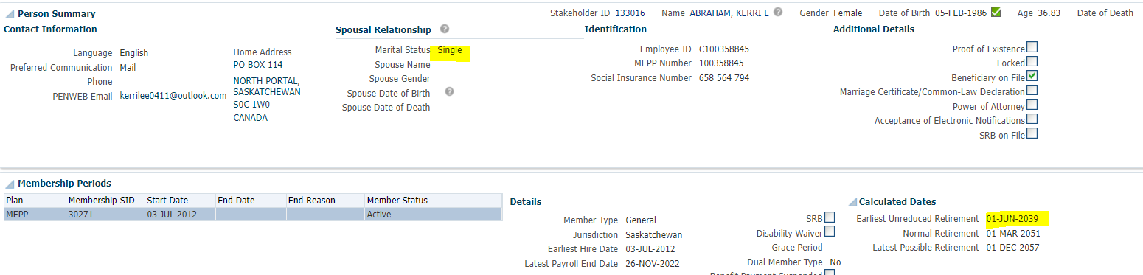

Terminate member

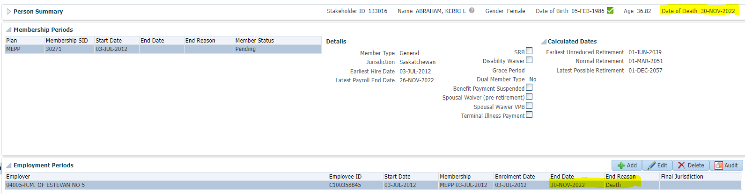

To Benefit Calculation>Calculate

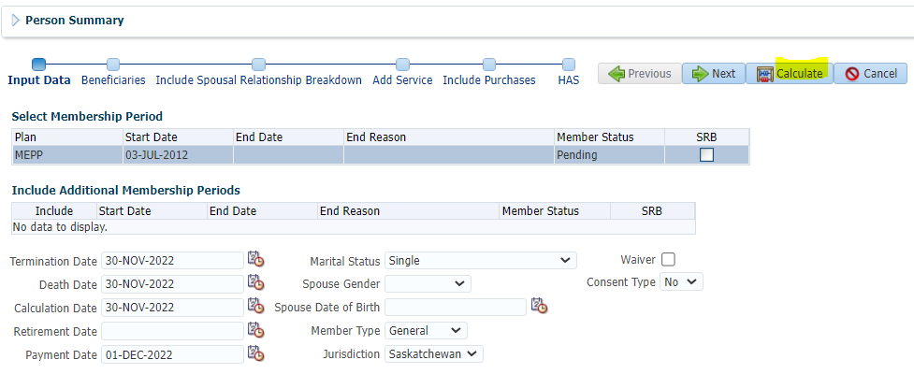

Process

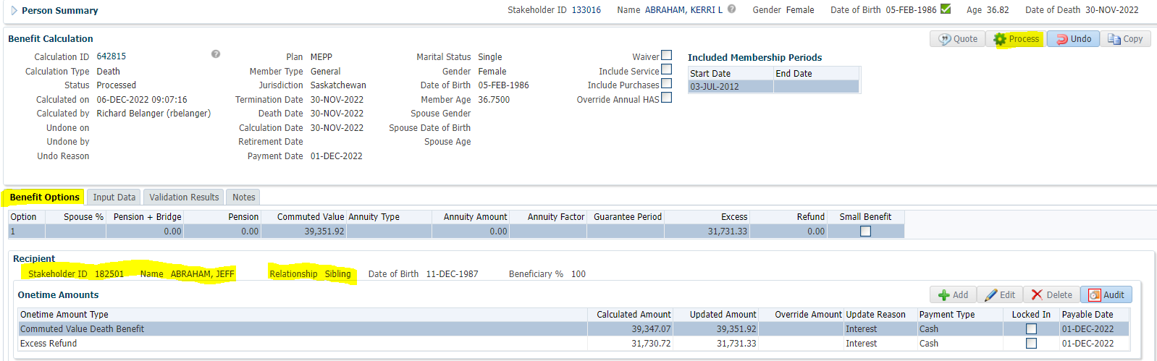

Processed>To Benefit Selection>Next

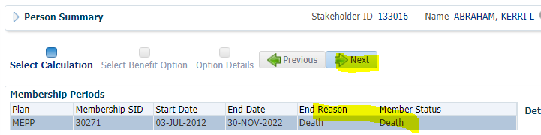

Next

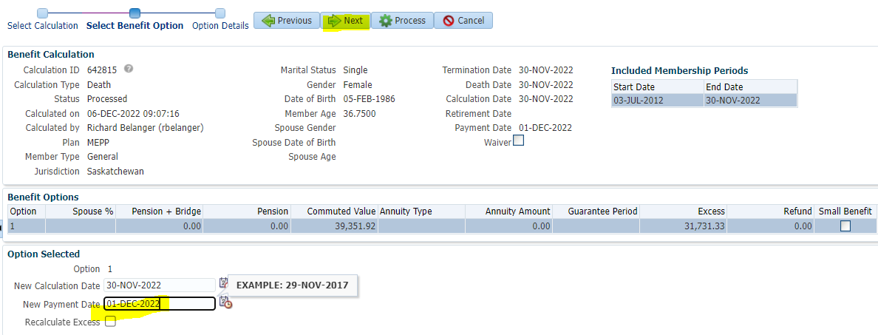

Payment Instructions added; Tax Instructions added>Process

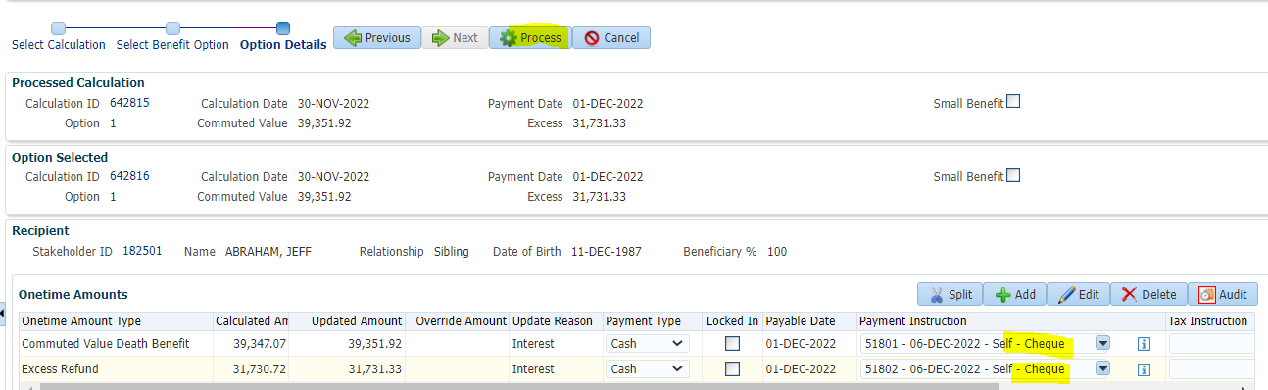

Member is terminated



To Benefit Recipient (Sibling-Beneficiary)

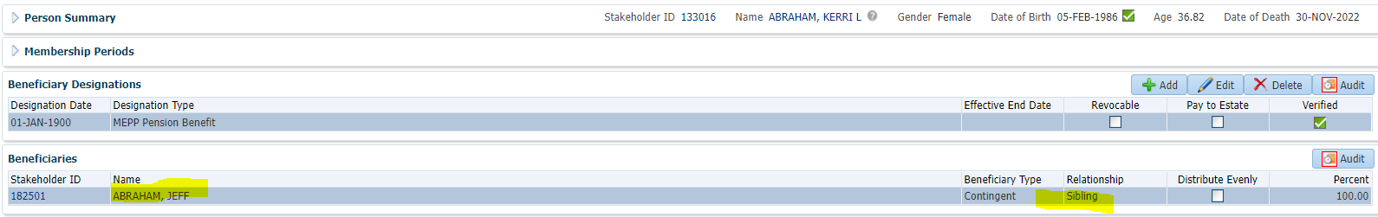

Submit, Approve and Authorize the payment

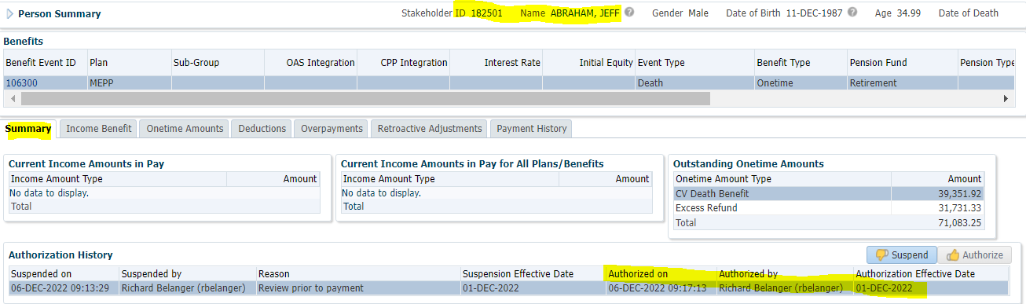

Run payment for beneficiary’s death benefit>Payment History

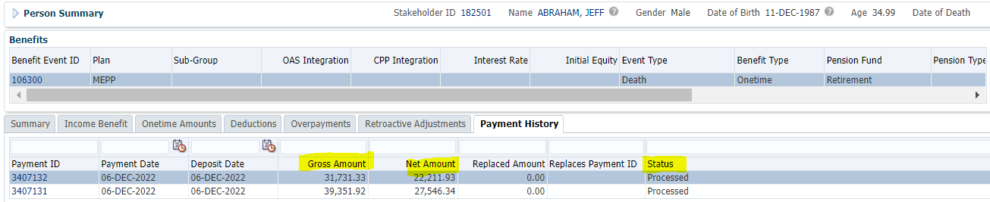

Tax Rates

0.00-4,999.99 = 10%

5,000.00- 14,999.99 = 20%

15,000.00+ = 30%

39,351.92 + 31731.33 = $71,083.25; Taxes taken from full amount

71083.25 x 30% = 21324.98; 71083.25 – 21324.98 = **$49,758.27; $22,211.93 + $27,546.34 = $49,758.27**